

G2 EE

Issue Unplanned

QAD EE Training Document

Issue Unplanned

Table of Contents
Objective 3
Department Maintenance 14.1 3
*Issues – Unplanned 3.7 3
*Transactions Type/Loc. Report 3.21.15 5

Objective
Purpose of this document is to explain the Issue Unplanned process
Issue Unplanned is used to remove part from the system that do not fall into other categories. Before performing an Issue Unplanned booking ensure that it should not better be booked as Scrap, RTV or CC. Shipments to the customer where a SO is available or receipts where a SA is available should also never be booked using ISS-UNP.

Department Maintenance 14.1
Use this menu to maintain the Departments which must be entered during the ISS-UNP booking.
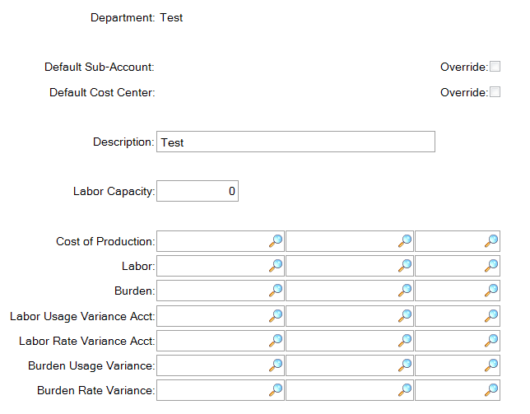
Enter data as required and confirm.

*Issues – Unplanned 3.7
Enter the item number to be booked and press Enter/ click Next:
Enter the relevant data in the next section.
Caution: ISS-UNP automatically negative posts a negative quantity, so entering Quantity: 5 will cause a booking of -5 pcs. To post a positive quantity enter it in the negative (e.g. -5)
Inv Movement Code and Department must be entered. Never use 006 or 007 here, these should be booked according to the Cycle Count and Scrap processes. Ensure the correct location is entered under Loc. Click Next.
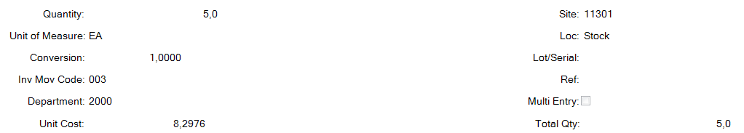
In the next section the Reason Code is compulsory. Click on the Magnifying Glass to view the available codes. This is important information for the accounting team. The loss or gain created by this transaction must be justified and clearly accounted for based on these codes.
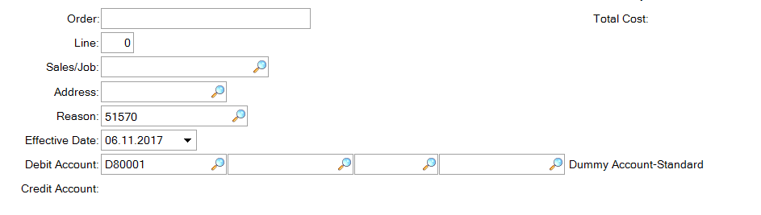
Available Reason Codes:
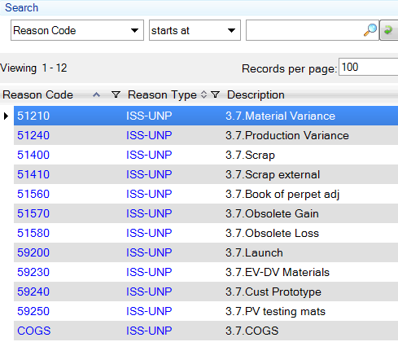

Having selected the appropriate Reason Code click Next or press enter.
You will be asked if all information is correct, click Yes to perform the transaction.
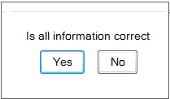

*Transactions Type/Loc. Report 3.21.15
This report can be used to view Issue Unplanned transactions in the system. Enter the transaction name under Transaction Type and any other parameters as required.
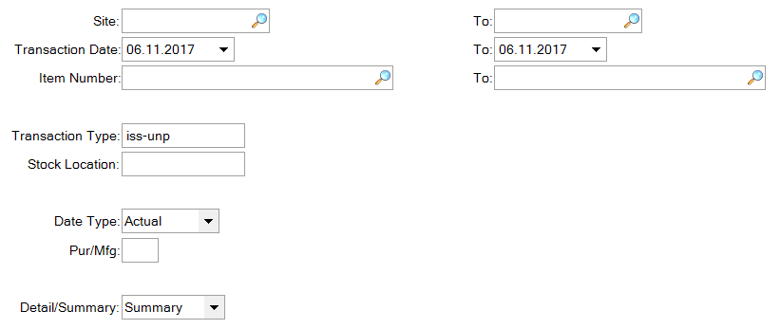
If you leave output as page a report will automatically be created showing the related bookings, here for example:
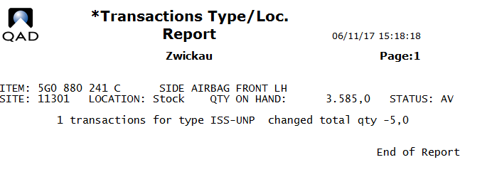
To export to Excel:
By entering an output name when creating the report it will then be available in the plant’s home directory to be transferred using the local file transfer tool (typically WIN SCP) and then opened in Excel.

